**For more information: Press Release**

**JBL Greece ( Official Distributor WaveMotion S.A)** For direct publication.

Tel.:210-9244505 Date:04/11/24

Email: [jbl_greece@wavemotion.gr](mailto:jbl_greece@wavemotion.gr)

**RACE 2 WIN: JBL awaits you at the OPAP MARATHON EXPO 2024!**



Athens – November 4rth, 2024. WaveMotion S.A., the official distributor of JBL lifestyle audio products for the Greek market, will participate for the second consecutive year in the OPAP MARATHON EXPO, held just before the Athens Authentic Marathon. The OPAP MARATHON Expo 2024, the official exhibition for the 41st Athens Authentic Marathon, will take place from November 6 to 9, 2024, at the exhibition center of the P. Faliro Indoor Arena (formerly TAE KWON DO). The countdown has already begun!

JBL will be there with its top Sports and Lifestyle products, supporting you every step of the way from start to finish with its legendary sound. You'll also have the chance to experience firsthand the capabilities of its Soundgear and Endurance products. Among them, you’ll find the new model, **Endurance Race 2**, designed to withstand even the toughest conditions alongside you, enhancing your performance.

**JBL Endurance Race 2**

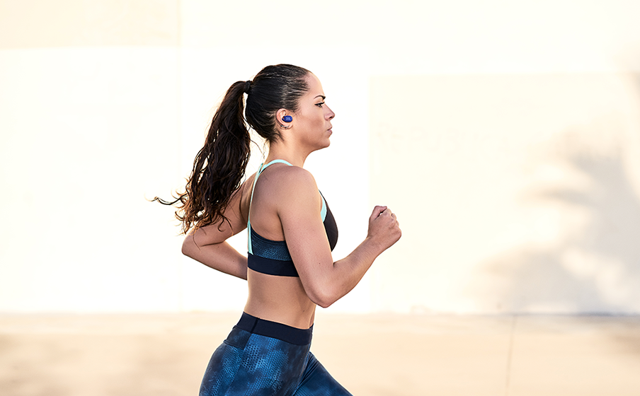 Stay focused and ready to move with JBL Endurance Race 2 true wireless active earbuds. With 48 hours of battery life* and an IP68 waterproof and dustproof design, they’re built to keep going strong in even the most challenging workout conditions. Their superior fit with optimum sealing, stability in your ears, and all-day comfort, will keep you active from the beach to the boardroom. Powerful 6.8mm dynamic drivers deliver JBL Pure Bass sound. Keep your focus with Active Noise Cancelling, while Smart Ambient technology keeps you aware of your surroundings. Adjust the Sports Mode settings to the intensity of your workout, choosing one of the six default settings in the JBL Headphones App – or customize your own. And with the ability to make crystal clear calls from anywhere, you’ll stay connected to the world no matter where your workout takes you. (*with ANC off)

* Waterproof and dustproof
* Ergonomic wing enhancer with Twistlock™ technology
* Enhance your work-out with ‘Sports Mode’
* Active Noise Cancelling with Smart Ambient
* 4 mics for crisp, clear calls
* JBL Pure Bass sound
* 48 hours of playback time, plus speed charging
* Multi-point connection
* Seamless Bluetooth® pairing
* Available in 2 colors: black and white

Join us at the largest sports goods exhibition, Marathon Expo, at the P. Faliro Indoor Arena (formerly TAE KWON DO) to discover the new Endurance Race 2 sports earbuds, the popular Partybox in a new white color, and many exciting surprises and offers, along with a super contest! Find us at booth 50A from Wednesday, 06/11 to Saturday, 09/11.

Operating Hours:

Wednesday 06/11: 13:00 – 20:00

Thursday 07/11: 10:00 – 20:00

Friday 08/11: 10:00 – 20:00

Saturday 09/11: 08:00 – 19:00

More information can be found at

[Home | JBL (jblgreece.gr)](https://www.jblgreece.gr/)

and our social accounts [Facebook](https://www.facebook.com/JBLGreece) ,  [Instagram](https://www.instagram.com/jbl_greece/), [Tiktok](https://www.tiktok.com/@jbl_greece?lang=en)

**About WaveMotion**

WaveMotion, an importer and distributor, is seated in Athens Greece, operating on a wholesale basis, in the consumer electronics, telecommunications and computer industry for over 35 years. WaveMotion S.A. retains the official, exclusive, distribution for the Greek market of important Houses- in leading positions in the Global Arena, like JBL, harman/kardon, Cambridge Audio, Q Acoustics, QED, Goldring, rapoo, Native Union, Livall. Brand Development is the core skill of WaveMotion Team. The vision of our people is to expand WaveMotion’s Brands selection, following our tagline’s principles –Technology, Aesthetics, Design- and continue this journey of Ours, introducing compellingly and establishing decisively these Brands, in the eyes of our Customers.

**About HARMAN**

HARMAN (harman.com) designs and engineers connected products and solutions for automakers, consumers, and enterprises worldwide, including connected car systems, audio and visual products, enterprise automation solutions; and services supporting the Internet of Things. With leading brands including AKG®, Harman Kardon®, Infinity®, JBL®, Lexicon®, Mark Levinson® and Revel®, HARMAN is admired by audiophiles, musicians and the entertainment venues where they perform around the world. More than 50 million automobiles on the road today are equipped with HARMAN audio and connected car systems. Our software services power billions of mobile devices and systems that are connected, integrated and secure across all platforms, from work and home to car and mobile. HARMAN has a workforce of approximately 30,000 people across the Americas, Europe, and Asia. In March 2017, HARMAN became a wholly-owned subsidiary of Samsung Electronics Co., Ltd..