**For more information: Press Release**

**JBL Greece ( Official Distributor WaveMotion S.A)** For direct publication.

Tel.:210-9244505 Date:09/12/24

Email: [jbl_greece@wavemotion.gr](mailto:jbl_greece@wavemotion.gr)

**SOUNDS LIKE CHRISTMAS! JBL accompanies you at this year’s Christmas!**

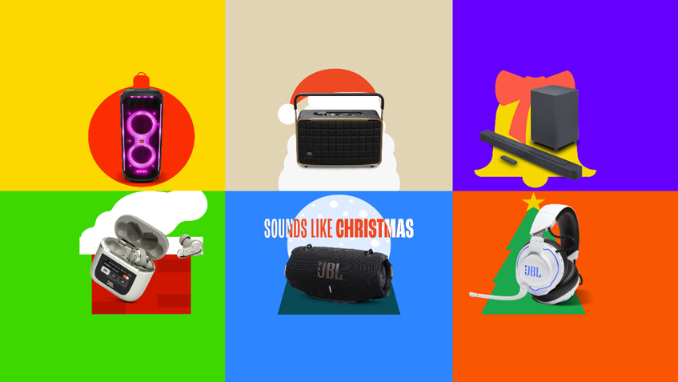

Athens – December 9th, 2024. WaveMotion S.A., the official distributor of JBL lifestyle audio products for the Greek market, welcomes the festive season with a campaign that brings the sound of Christmas. With Christmas approaching, and along with the cold weather and moments with our loved ones, sounds and songs that we have all hummed or shouted in dance during the holiday season come to our ears again. This year, however, beyond the songs and carols, we will also hear our wishes and dreams a little louder with JBL giving sound to our every moment and thought. Speakers, headphones, soundbars and Partyboxes become the best gifts for our loved ones, but also the best company.

With the message “Sounds like Christmas”, the campaign takes us on a journey through our favorite Christmas memories, while inviting us to create new ones with the sound of JBL with us. The campaign is accompanied by a series of visuals depicting classic elements and moments of the holidays, reminding us that just like Christmas, JBL is always a reference point in our favorite moments.

**Speakers**

Discover a wide variety of speakers that will be the ideal gift for your loved one this Christmas. From the GO4 or Clip 5, small in size but with long battery life, to the medium size with powerful sound that you will find in the Flip 6 or Charge 5 and the ultimate Partybox party speakers for Christmas events and parties on a new level.

**Headphones**

Whether you're looking for over-ear or in-ear headphones, JBL has you covered! Find the model and color that suits you and elevate your or your loved ones' everyday life. With features like Active Noise Cancelling, Smart Ambient, a waterproof indicator, and JBL Pure Bass sound, calls are made easier and music is louder.

**Gaming**

If you're planning to upgrade your experience with your new games this holiday season, you need the right equipment. Find different gaming headsets that will take you to the heart of the game with accurate and powerful sound. Choose the type of microphone that suits you between Quantum Stream Studio, Triple Condenser Microphone, Quantum Stream Talk, Condenser Microphone and Quantum Stream Wireless to stream endless hours with your friends.

**Soundbars**

JBL Soundbars feature immersive Dolby Atmos® sound to make you feel like you're inside the movie you're watching, and various streaming services like AirPlay, Alexa Multi-Room Music and WiFi to connect quickly and easily. Upgrade your space and give your entertainment a new audiovisual angle.

Find gifts for music lovers, for those who always want to have their favorite playlists with them, for those who prefer to stay home with good company, for those who will always have exercise in their New Year's Resolutions, for those who will never part with their PC, but also for those who always remain faithful to classic values.

Dress your gifts with JBL's legendary sound for guaranteed success.

More information can be found at

[Home | JBL (jblgreece.gr)](https://www.jblgreece.gr/)

and our social accounts [Facebook](https://www.facebook.com/JBLGreece) ,  [Instagram](https://www.instagram.com/jbl_greece/), [Tiktok](https://www.tiktok.com/@jbl_greece?lang=en)

**About WaveMotion**

WaveMotion, an importer and distributor, is seated in Athens Greece, operating on a wholesale basis, in the consumer electronics, telecommunications and computer industry for over 35 years. WaveMotion S.A. retains the official, exclusive, distribution for the Greek market of important Houses- in leading positions in the Global Arena, like JBL, harman/kardon, Cambridge Audio, Q Acoustics, QED, Goldring, rapoo, Native Union, Livall. Brand Development is the core skill of WaveMotion Team. The vision of our people is to expand WaveMotion’s Brands selection, following our tagline’s principles –Technology, Aesthetics, Design- and continue this journey of Ours, introducing compellingly and establishing decisively these Brands, in the eyes of our Customers.

**About HARMAN**

HARMAN (harman.com) designs and engineers connected products and solutions for automakers, consumers, and enterprises worldwide, including connected car systems, audio and visual products, enterprise automation solutions; and services supporting the Internet of Things. With leading brands including AKG®, Harman Kardon®, Infinity®, JBL®, Lexicon®, Mark Levinson® and Revel®, HARMAN is admired by audiophiles, musicians and the entertainment venues where they perform around the world. More than 50 million automobiles on the road today are equipped with HARMAN audio and connected car systems. Our software services power billions of mobile devices and systems that are connected, integrated and secure across all platforms, from work and home to car and mobile. HARMAN has a workforce of approximately 30,000 people across the Americas, Europe, and Asia. In March 2017, HARMAN became a wholly-owned subsidiary of Samsung Electronics Co., Ltd..