**For more information: Press Release**

**JBL Greece ( Official Distributor WaveMotion S.A)** For direct publication.

Tel.:210-9244505 Date:24/1/25

Email: [jbl_greece@wavemotion.gr](mailto:jbl_greece@wavemotion.gr)

*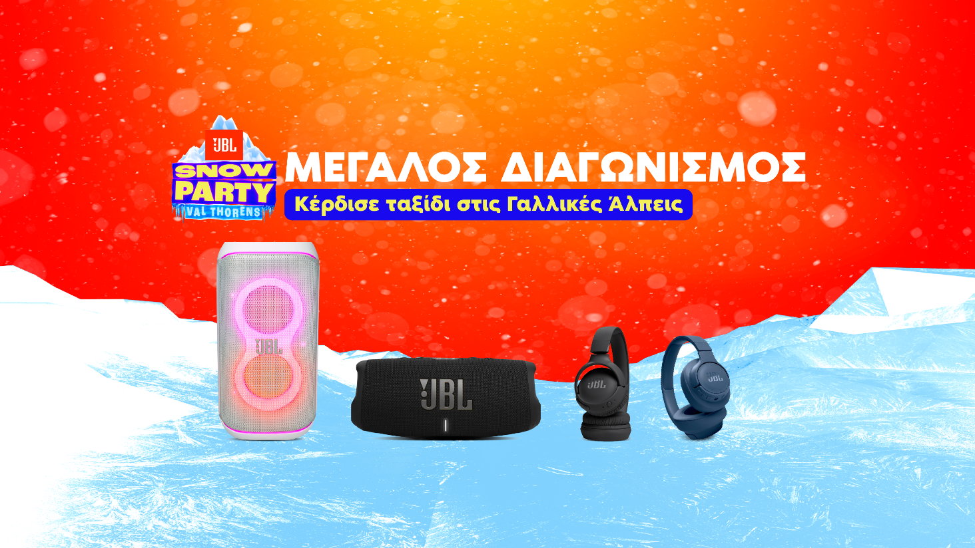***JBL Snow Party celebrates music and spectacular sound in the Alps again this year!**

***3 action-packed days at a ski resort, VIP parties and live performances at the most disruptive event of the winter. Get the chance to be in Val Thorens in the French Alps at the biggest Snow Party ever by purchasing a JBL product.***

Athens – 24th January 2025. JBL Greece (Officially Distributed by WaveMotion S.A.) for another year in a row announces the competition for buyers of JBL products. And in 2025, JBL is giving you and a friend the chance to take part in the annual Snow Party happening on April 16 through 19th in the French Alps to have fun, do winter activities and meet DJ Martin Garrix up close. The participation period starts from 18/01/2025 and ends on 24/02/2025.

The steps are simple:

1. Buy any JBL product from the official stores or the e-shop of [Plaisio](https://www.plaisio.gr/search?query=jbl), the official [JBL](https://www.jblgreece.gr/) e-shop and [WaveMotion Gallery](https://wavemotiongallery.gr/)’s online and instore until the 24th of February
2. Visit the official [JBL Snow Party 2025](https://eu.jbl.com/snowparty-2025-gr.html) page and submit your information in order to participate

**Welcome to JBL Snow Party**

 Get ready for the ultimate Snow Party experience, on and off the slope. Board a round-trip flight and follow JBL to the all-inclusive resort of Val Thorens, with ski-to-door access, stunning mountain views and a unique Club Med dining experience.

Val Thorens is located in the Savoie region of France and is Europe's highest resort, bringing fresh snow from November to May.



**Enjoy unique winter activities.**

Bring your sense of adventure to the mountain and engage in the sports and winter activities that the mountain offers. Hit the slopes with confidence - there are routes for every experience level - or get ready for sledging, climbing and of course the ultimate apres-ski party.

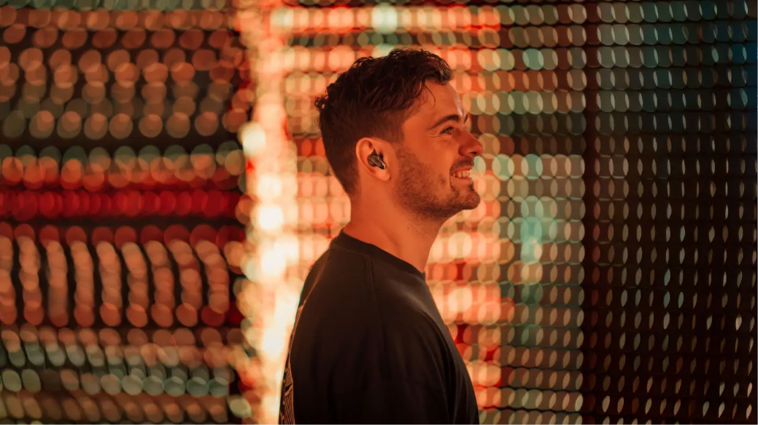**Experience the ultimate party!**

Enjoy another day on the slopes and get ready for an night full of rhythm. Join us at the JBL Altitude Party and keep dancing at the Après Ski Party, to the beats of the famous DJ and music producer Martin Garrix!

Relax at the hotel before returning home. Come back with amazing memories and epic photos for your Social media.

Join us for the 6th Annual JBL Snow Party for a weekend full of snow, music, sports and more!

Find out more here:

[JBL Snow Party 2025](https://eu.jbl.com/snowparty-2025-gr.html)

More information on our site [Home | JBL (jblgreece.gr)](https://www.jblgreece.gr/)

And our socials [Facebook](https://www.facebook.com/JBLGreece) ,  [Instagram](https://www.instagram.com/jbl_greece/), [Tiktok](https://www.tiktok.com/@jbl_greece?lang=en)

**About WaveMotion**

WaveMotion, an importer and distributor, is seated in Athens Greece, operating on a wholesale basis, in the consumer electronics, telecommunications and computer industry for over 35 years. WaveMotion S.A. retains the official, exclusive, distribution for the Greek market of important Houses- in leading positions in the Global Arena, like JBL, harman/kardon, Cambridge Audio, Q Acoustics, QED, Goldring, rapoo, Native Union, Livall. Brand Development is the core skill of WaveMotion Team. The vision of our people is to expand WaveMotion’s Brands selection, following our tagline’s principles –Technology, Aesthetics, Design- and continue this journey of Ours, introducing compellingly and establishing decisively these Brands, in the eyes of our Customers.

**About HARMAN**

HARMAN (harman.com) designs and engineers connected products and solutions for automakers, consumers, and enterprises worldwide, including connected car systems, audio and visual products, enterprise automation solutions; and services supporting the Internet of Things. With leading brands including AKG®, Harman Kardon®, Infinity®, JBL®, Lexicon®, Mark Levinson® and Revel®, HARMAN is admired by audiophiles, musicians and the entertainment venues where they perform around the world. More than 50 million automobiles on the road today are equipped with HARMAN audio and connected car systems. Our software services power billions of mobile devices and systems that are connected, integrated and secure across all platforms, from work and home to car and mobile. HARMAN has a workforce of approximately 30,000 people across the Americas, Europe, and Asia. In March 2017, HARMAN became a wholly-owned subsidiary of Samsung Electronics Co., Ltd..