For more information: Press Release
JBL Greece ( Official Distributor WaveMotion S.A) For direct publication.
Tel.:210-9244505 Date: 28/3/25
Email: : Partners@WaveMotion.gr

The new Harman Kardon Onyx Studio 9 combines timeless design with innovative new features!

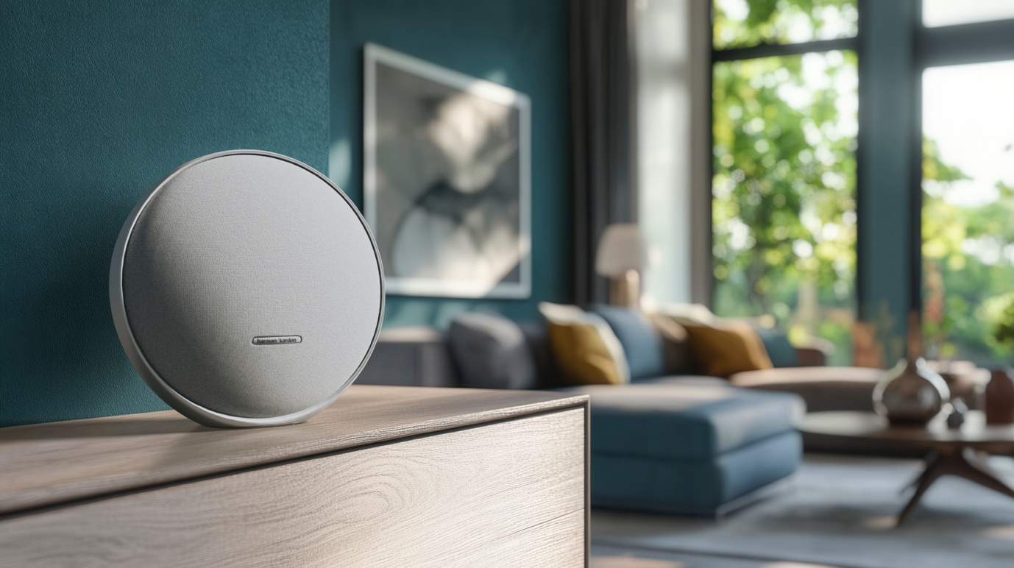

Athens – March 28th , 2025 – WaveMotion S.A., the official distributor of harman/kardon in Greece, presents the new Harman Kardon Onyx Studio 9. This reimagined classic speaker combines iconic design with innovation! With a refreshed aesthetic that honors the timeless silhouette of its predecessors and new Constant Sound Field (CSF) technology, the Onyx Studio 9 delivers the most impressive sound to date. Thanks to Auracast you achieve unstoppable connectivity from multiple devices simultaneously, enjoying a more flexible and dynamic audio experience brings audio performance and flexibility to the next level!


Enjoy upgraded sound from the comfort of your home. HARMAN's new CSF acoustic algorithm blends music across the three channels of the speaker, delivering it through each tweeter, putting you at the center of every soundtrack. Create an even more immersive experience with Auracast. Connect the speaker to another Harman Kardon Onyx Studio 9 speaker or any other Auracast-enabled Harman Kardon speaker and place them around the room or home to listen to your playlists in a new dimension.

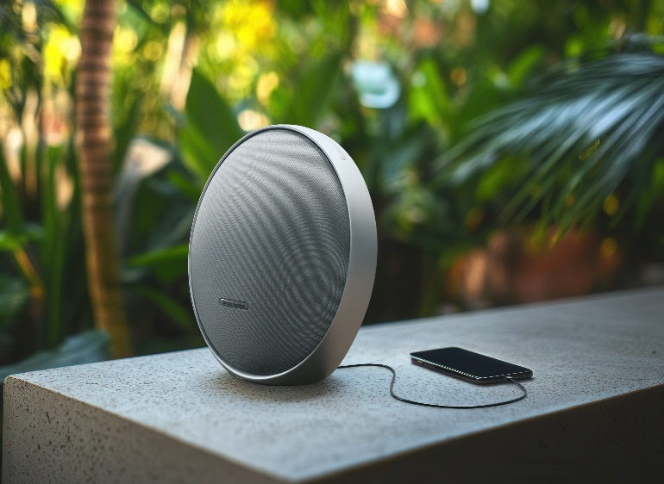
Onyx Studio 9's auto-adaptive technology optimises the sound according to its environment, ensuring the best possible quality wherever you place it. With the new Harman Kardon ONE App, you can take full control of the sound and tailor it to your personal taste!

Taking inspiration from the existing range, the Harman Kardon Onyx Studio 9 features a sleek, circular design that complements any interior. Now with an integrated handle, aluminium base and user interface, it's sleek, ergonomic and convenient to use.

The Harman Kardon Onyx Studio 9 will be available in Classic Black and Stone Grey for €249.99 and other authorized retail channels.

More information on our site harman / kardon® - Wavemotion
And our socials Instagram, Facebook

About WaveMotion
WaveMotion, an importer and distributor, is seated in Athens Greece, operating on a wholesale basis, in the consumer electronics, telecommunications and computer industry for over 35 years. WaveMotion S.A. retains the official, exclusive, distribution for the Greek market of important Houses- in leading positions in the Global Arena, like JBL, harman/kardon, Cambridge Audio, Q Acoustics, QED, Goldring, rapoo, Native Union, Livall. Brand Development is the core skill of WaveMotion Team. The vision of our people is to expand WaveMotion’s Brands selection, following our tagline’s principles –Technology, Aesthetics, Design- and continue this journey of Ours, introducing compellingly and establishing decisively these Brands, in the eyes of our Customers.

About HARMAN
HARMAN (harman.com) designs and engineers connected products and solutions for automakers, consumers, and enterprises worldwide, including connected car systems, audio and visual products, enterprise automation solutions; and services supporting the Internet of Things. With leading brands including AKG®, Harman Kardon®, Infinity®, JBL®, Lexicon®, Mark Levinson® and Revel®, HARMAN is admired by audiophiles, musicians and the entertainment venues where they perform around the world. More than 50 million automobiles on the road today are equipped with HARMAN audio and connected car systems. Our software services power billions of mobile devices and systems that are connected, integrated and secure across all platforms, from work and home to car and mobile. HARMAN has a workforce of approximately 30,000 people across the Americas, Europe, and Asia. In March 2017, HARMAN became a wholly-owned subsidiary of Samsung Electronics Co., Ltd..

